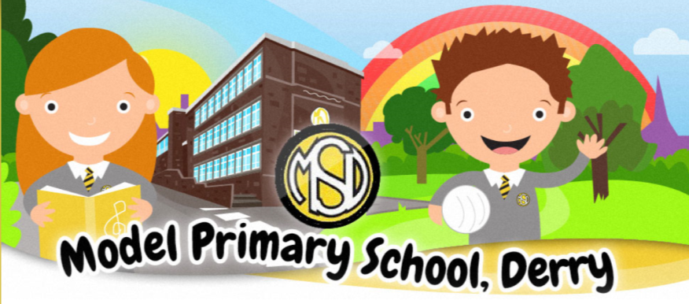

Positive
Behaviour
Policy
Policy Date: 2022
Reviewed: April 2024
Positive
Behaviour
Policy

PROMOTING POSITIVE BEHAVIOUR POLICY

Introduction

This policy reflects the philosophy, aims and procedures in promoting positive behaviour at the Model Primary School and Nursery Unit.

Rationale

The promoting positive behaviour policy of this school is based on the premise that good discipline is essential for effective learning to take place.

Within the school as a whole, effective discipline results in a positive school ethos that reflects order, safety, respect and dignity.

Within each classroom this provides a safe environment for quality teaching and learning.

Within each pupil such an environment should lead to a sense of security, promoting high self -esteem and a recognition of the positive qualities, which they can contribute to the school. In the Model, a proactive rather than a reactive approach is taken to discipline, which ensures that a positive ethos exists.

Aims

To provide a positive learning environment for all pupils.
To provide a safe working environment for all pupils and staff.
To promote self – esteem in all pupils.
To promote self – control in all pupils.

Practice and Procedure

Key Legislation;

- Health and Safety at Work NI Order 1978
- The Children (Northern Ireland) Order 1995
- The Human Rights Act 1998
- The Education (Northern Ireland) Order (1998) Article 3 - see DE 1998/25
- Welfare and Protection of Pupils Education and Libraries (Northern Ireland) Order, 2003 - see DE 2003/13
- The Education (2006) Order, (Commencement No.2) Order (Northern Ireland) 2007- see DE 2007/20
- The Education (School Development Plans) Regulations (Northern Ireland) 2010
- Addressing Bullying in Schools Act (Northern Ireland) 2016

Consistency is integral to effective practice in the school. To ensure this, certain procedures have to be agreed by all staff and these will be supplemented by regular and open communication as and when any problems arise.

The school recognises the importance of developing a suitable learning environment in preventing serious problems.

This includes:

- Provision of an interesting and relevant environment;
- Development of a positive classroom ethos, which promotes respect and dignity for all;
- Maintaining good channels of communication;
- Consistency of approach

At the start of each school year, a positive structured approach to discipline is implemented. At our Parent Information sessions in September a Code of Conduct for behaviour is shared by the Principal or Vice-Principal with parents. Regular assemblies by the Senior Leadership Team focus on expected behaviour. Classroom rules are established in conjunction with the pupils and displayed in the classroom.

Positive behaviour is to be acknowledged and reinforced through a system of rewards within each class. Inappropriate behaviour is to be responded to by a line of consequences of increasing severity which may include the following:

- The pupil will be told that his/her behaviour is inappropriate
and be given the opportunity to modify it.

2. If the pupil ignores the reminder, he/she will be given a final warning and made aware that further action will take place if the behaviour continues.

3. The pupil is given “time out” and seated at a single desk away from his/her peers.

4. The pupil is asked to work for a short time in another classroom. This may be for a short time at break or lunchtime at the teacher’s discretion. The pupil may be asked to miss a break.
5. If, after applying these steps, no improvement in behaviour or attitude is evident, the pupil will be sent to the head of Key Stage/Vice-Principal.

6. If, after applying these steps, no improvement in behaviour or attitude is evident, the pupil will be sent to the Principal.

7. The pupil’s parents are informed and withdrawal of privileges may be considered. These will be appropriate to the situation and the child’s age. Care will be taken not to jeopardise the delivery of the curriculum and the sanctions may include: -

- exclusion from an extra-curricular activity
- any child whose behaviour endangers other pupils may be excluded from school premises at lunchtime and parents will be expected to make arrangements for supervision.
- Any pupil whose behaviour endangers other pupils may be excluded from outings or school trips.

8. If, after these interventions have taken place, no visible improvement in the pupil’s behaviour is evident, the pupil may be placed at STAGE 1 of the Code of Practice for Special Education Needs. This will only occur after consultation between SENCO, the class teacher and the parents. At this point an Individual Education Plan (IEP) will be drawn up specifically to target the special behavioural needs of the child.

9. The pupil’s behaviour will continue to be monitored very closely and if no improvement is apparent then advice may be sought from EA Support agencies. (E.g. Educational Welfare Officer; Educational Psychologist; Adviser from the Behavioural Support Team.)
The pupil may progress to stage 2 of the Code of Practice for Special Education Needs should these agencies become involved.

Pupils with high risk behaviour

- A risk assessment should be carried out for those pupils who present with very challenging behaviour. These should be reviewed every 6 weeks or when a serious incident occurs.
- The content of the risk assessment must be shared with parents and pupils.
- Pupils who have difficulty attending school for the whole day will follow an amended timetable so we can focus on the positive. The school will endeavour to increase the school day only when we feel the pupil is ready. Parents will meet to discuss and will sign the amended timetable agreement letter.

Use of Positive Handling techniques:
Occasions may arise when staff feel that despite having used other strategies (including de-escalation) the child remains vulnerable to harm of him/herself or others. In this case the staff may feel that the child needs to be restrained using positive handling techniques.
The school will follow the Guidance as per Circular Number: 2021/13Interim Guidance on the Use of Restraint and Seclusion in Educational Settings.

Extremely serious misconduct may result in suspension or expulsion under the terms set out by EA and this is applicable to all children in the school. (Scheme for the suspension and expulsion of pupils in Controlled Schools) The chair of the Board of Governors and the Education Authority will be informed if a child is suspended. Discipline and Anti – Bullying will be a fixed agenda on each Board of Governors meeting (under Pupil Issues) The school will always carry out a return to school meeting with both the parent/guardian and child outlining the expected behaviour.

The following are regarded by the Department and the Board as valid reasons for suspension or expulsion:
- Substance or alcohol abuse on school premises
- Persistent bullying of a pupil
- Physical attack/abuse of a pupil or member of staff
- Verbal abuse of a pupil or member of staff
- Disruptive behaviour in class
- Persistent infringements of relatively minor school rules
- Significant damage to school, staff or pupils’ property, either in or outside school
- Stealing from school, staff or pupils, in or outside school
- A very serious problem/unforeseen incident may result in the normal procedures being set aside and a child’s parent/guardian being asked to remove the child for the remainder of the school day.

Working with Parents

It will be the responsibility of the teacher to maintain a good working relationship with the parents of all pupils. If minor problems arise they are to be communicated to the parents in an informal way such as a phone call, a note in the home/school diary. Parents in Primary 1 & 2 are in daily contact with the class teacher. The school encourages a quick response to parent’s concerns. Parents are also encouraged to discuss any problems that may arise at home or keep teachers informed of any changes in the pupil’s circumstances, which may have an effect on their behaviour.

They will be invited to discuss the issue as well as any strategies, which may be used. Where appropriate, parents will be asked to support such strategies at home.

Parents will be informed of the situation and asked for their permission before the involvement of any outside agency. They should already be aware of the nature of the difficulties that their child is causing in the classroom from previous communication.

Monitoring and Evaluation

It is the responsibility of the management of Model Primary School to implement the procedures outlined above. Their effectiveness is to be reviewed at senior management team meetings regularly. Ongoing monitoring of the procedures is the responsibility of the Principal and such monitoring will be carried out informally through discussions with staff.

Each Teacher is responsible for:

His/her own behaviour as a role model for children.

Promoting habits of courtesy, good order, fairness within and without the classroom.

Using the agreed intervention strategies, level 1-4 outlined in the booklet Effective responses to bullying behaviour NIABF 2003 (APPENDIX 1)

Providing a challenging, interesting and relevant curriculum.

Providing a welcoming, safe and supportive classroom environment.

Forming positive relationships with parents and pupils.

Teaching the personal, social and emotional skills and abilities that underpin the school’s behaviour curriculum.

Using PATHS programme as a whole school, consistent approach

Maintaining a record of all incidents in the Behaviour Log. Informing parents/guardians if required and next steps. Monitoring behaviour following an incident.

Ensure the Principal is informed of any critical incidents.

Each pupil is responsible for:

His/her own behaviour.

Following the classroom rules, the playground rules and the code of conduct.

Trying his/her best both within and without the classroom.

Managing and being respectful of his/her own belongings and those of others.

Being courteous and considerate towards others.

The Senior Leadership team are collectively responsible for:

Being on call during break/lunch and throughout the day to respond to any incidents of poor behaviour.

Regular assemblies with a positive behaviour message.

Providing training for all staff (including lunchtime supervisors) and ensuring behaviour is a regular agenda item at staff meetings.

Good behaviour in corridors, toilets, cloakrooms, hall and playground.

Monitoring of general standards of behaviour throughout the school.

Consistently following the agreed procedures and rules described in this policy.

Parents are responsible for:

Good attendance and punctuality.

Supporting the aims and values implicit in the school behaviour policy.
Supporting our PATHS programme.

Ensuring that their children bring to school daily the necessary equipment (books, pens, pencils, sports gear etc).

Ensuring that the school is aware of any reason that the child’s behaviour may be affected due to change of circumstance at home.

Pupils’ Rights:

Pupils have the right to unimpeded access to learning.

Pupils have a right to work in a safe and secure environment.

Pupils have a right to be treated in a fair manner and to discuss issues of concern to them in calm and reasonable atmosphere.

Pupils have a right to be free from consistent threatening behaviours against them.
The school council will regularly discuss behaviour and any suggestions will be considered for the benefit of all children.

Teachers’ Rights

Teachers have the right to teach without harassment or unwarranted disruption. Any incidents of verbal abuse or physical assault will be taken seriously and will result in parents being notified and may result in a suspension. This is applicable to all pupils within our school.

Pupils’ and Teachers’ Rights

Pupils and teachers have a right to receive mutual respect.

Parents’ Rights

Parents have the right to expect that their child will be safe and cared for at school.

Signed: ____________ Date: ________

Chair of Governors

Review Date: ___________

