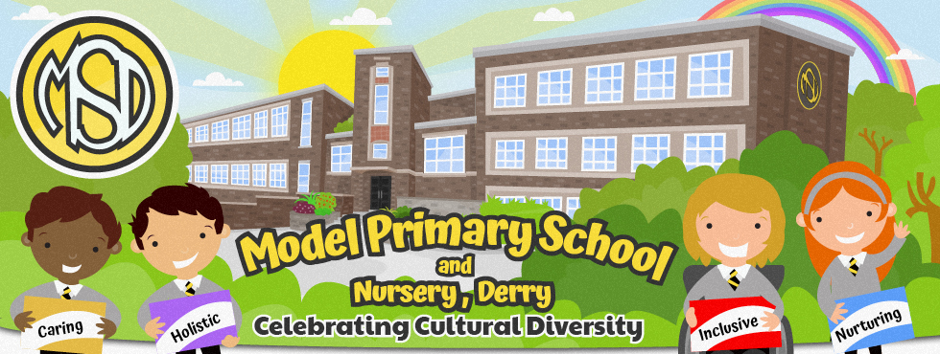 [Grab your reader’s attention with a great quote from the document or use this space to emphasize a key point. To place this text box anywhere on the page, just drag it.]

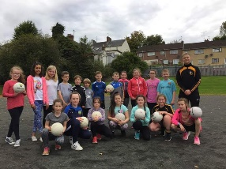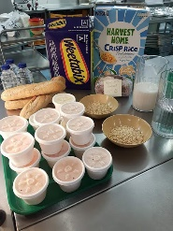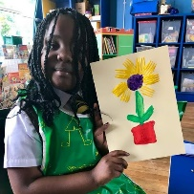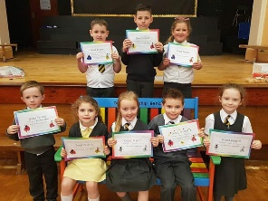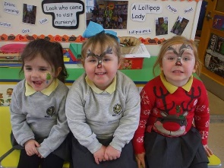

**Breakfast Club**

**Mrs Michelle Ramsey**

**Principal**

**Afterschool**

**Care to 4pm**

The Model welcomes parents of Nursery and Primary One children on

Wednesday 10th January

2.30pm – 5pm

OPEN DAY

Phone: 02871 262188

Email: [info@model.londonderry.ni.sch.uk](mailto:info@model.londonderry.ni.sch.uk)

Find us on Facebook and Twitter: Model Primary School / @modelprimaryschoolderry

**Extra Curricular**

**Clubs**