Dear Parents,
As we approach our half-term break I want to share some information with you.
I want to begin by sincerely thanking you for your understanding and support for our school during this very challenging time. As we find ourselves having to make very difficult decisions, your understanding, support and patience is something that we very much appreciate. We do not underestimate the challenges that you face in keeping your own children safe and engaged in their learning and social activities as well as managing the logistics of your own work, childcare and so on. This is so very difficult, and the only way we will get through is by continuing to work so positively together.
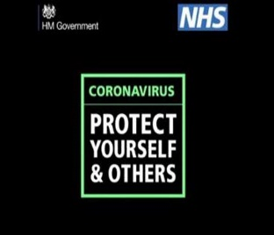
Managing Covid
If there is a positive case in your child’s class, we will inform you by text. If there is a cluster of Covid cases in one particular class, we will inform you by letter with specific instructions.
If your child is showing symptoms and is presenting with a negative Lateral Flow, it is advised that they should have a PCR test.
Please keep us informed at all times of any sickness or potential cases in your home and ensure you update us with their progress. There is an automated voicemail service for recording sick absences and we listen to the recordings daily and note reasons for absence and inform teachers.
Classrooms are fogged regularly and thorough cleaning is carried out daily.
Staff Sickness and Unavailability of Substitute
The rates of staff sickness continue to be very high across all of our school sectors and it is expected to continue for some time. Like most schools, we do not have the internal capacity to offset staff absence and will have to look for substitute staff externally. This is, however, almost impossible, given the serious shortage of available substitute teachers & LSAs.
It is also the case that I do not always have the flexibility to be able to supervise a class due to other core responsibilities that have to be attended to in order to maintain the safe running of the wider school. We are very fortunate to have a flexible staff who work together to ensure that all classes remain in school. However, if we cannot safely manage a class due to staff shortage we may need to move to a temporary period of remote provision, the level of which will be determined by the capacity and circumstances at the time.
Afterschool Clubs
Our class bubbles have prevented the spread of Covid across the school and has highlighted the effectiveness of maintaining class bubbles.
For this reason, I am going to delay the start of our Afterschool Clubs until the week beginning 28th February. I would hope that after the half term break the situation will settle down.
Patience
I sincerely hope that this extraordinary set of circumstances will be relatively short lived, and as we move out of this particular stage of the pandemic, circumstances in our school will return to a level of normality, for the sake of our children and school community. Until such times, however, please continue to be patient with us as we continue to strive for the best possible solutions for our children in these circumstances.
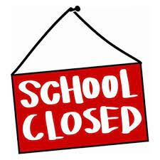
Dates for your Diary
School Closed
14-18th February Half term
17th & 18th March
18th March Staff Development Day
14th April (Half Day) to 22nd April Easter Holidays
Confirmation
Congratulations to all of our P7 children who took their Sacrament of Confirmation on Wednesday,9th February.
It was a lovely occasion. We thank Father Lagan and our staff in school who provided instruction and beautiful music.
Uniform/Lost Property.
Please ensure names are on all items of school uniforms, coats and lunch boxes. We have very large amounts of Lost Property in school. If names are on items of clothing, we can return these to you.
Children continue to be dressed smartly in full school uniform.
Please note P.E. uniform should be plain grey bottoms and a white polo shirt. Children can wear a plain grey zip up/sweatshirt or their school jumper.
Walking Home from School
Please note we require written permission if your child is walking home from school.
A signed letter or a note in his/her Homework Diary is sufficient. This is permitted from P5 to P7.
Younger children in P3 & P4 can walk home only with an older sibling.
Brooke Park Entrance
Just a reminder that our Brooke Park entrance is open daily from 8:15 to 9:15 and from 2:15 to 3pm daily for those families who wish to access school through the park in the mornings & afternoons. This has proved very successful.
Mrs Lamrock will begin a Walking Bus on Monday mornings (beginning Monday 21st February) as part of our Active Travel programme through Sustrans. Mrs Lamrock will meet children at the café in the park at 8.40 and walk them down to school. Walking to school has many physical as well as mental health and well-being benefits. This will also help to strengthen our sense of local community. Steven Ward our new rep from Sustrans will accompany Mrs Lamrock on Monday 21st February.
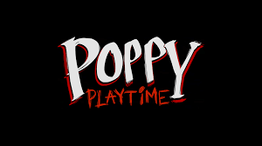
Poppy Playtime
Our online safety experts have been alerted to a video game, being described by some users as an “introduction to horror.” Videos, versions of the game, and associated material are becoming increasingly popular on YouTube, Roblox, and other platforms used by young children. Poppy Playtime features frightening images and themes that are paired with child-friendly items. This may be especially upsetting to children who have not yet developed the resilience to deal with disturbing content. To help parents, carers, and safeguarding professionals better understand these issues, we’ve taken a deeper look at Poppy Playtime and the wider genre it belongs to.
https://ineqe.com/2021/12/03/poppy-playtime-online-safety-review/

