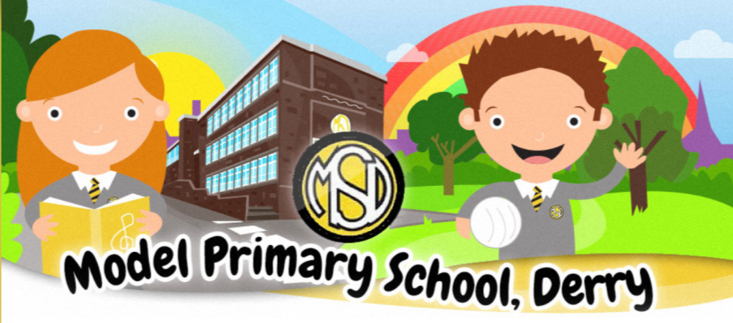
Anti–Bullying Policy
Policy Date: September 22
Review Date:_________________

Introduction

At the Model Primary School & Nursery unit we are committed to providing a happy, caring, friendly and safe learning environment for all our pupils so they can learn in a relaxed and secure atmosphere. Bullying behaviour of any kind will not be tolerated. At the Model we promote the rights of every child in accordance with the UNCRC. If bullying does occur, all children should be able to tell and know that incidents will be dealt with promptly and effectively. It is everyone’s responsibility to aim to prevent occurrences of bullying and to deal with any incidences quickly and efficiently.

Rationale

This policy is informed and guided by current legislation and DE guidance listed below:
- The Health & Safety at Work NI Order 1978 The Children (Northern Ireland) Order 1995,
- The Human Rights Act 1998,
- The Education (Northern Ireland) Order 1998 Article 3 – see DE 1998/25,
- DE Circular 2003/13 and Article 19,
- The Welfare & Protection of Pupils Education and Libraries (NI) Order 2003,
- The Education (2006 Order) (Commencement No. 2) Order (Northern Ireland) 2007 and
- The Addressing Bullying in Schools Act (Northern Ireland) 2016.

The Model Primary & Nursery School will put in place measures to help prevent all forms of bullying behaviour amongst pupils and determine policy details in consultation with staff and pupils. (See Appendix 1 for the legislative context & guidance materials).

Human rights issues as highlighted in ‘Human Rights Awareness for School Managers’ (Children’s Law Centre booklet) and training based on the most recent publication from Northern Ireland Anti-Bullying Forum (NIABF) ‘Effective Responses to Bullying Behaviour’ have also helped shape this policy.

Ethos & Principles

This document is based on Every School a Good School (DE 2009) and sets out our school’s policy and practice in relation to the care of pupils and the promotion of an environment where pupils and staff are continually:

Celebrating Diversity……Learning Together For Life
The Model Primary School and Nursery is committed to celebrating diversity in all aspects of school life through nurturing a love of learning and providing engaging opportunities in an inclusive environment where the aim for every child is that they might achieve their full potential. We are consistently learning together for life by developing the abilities and talents of every child, fostering respect, confidence, and creativity.

The Model Primary & Nursery School promotes the holistic development of every pupil. Care, welfare and safeguarding are the foundations that underpin the positive behaviour management within the school. The Model Primary & Nursery School provides a learning environment in which pupils feel safe and happy at school, and are challenged in their learning. Through careful planning, monitoring and evaluating the quality of provision, our school ensures that the learning environment encourages pupils to realise their potential and achieve success in all aspects of school life.
Consultation & Participation.

In reviewing this policy, we consulted with pupils through

- Class-based activities
- Whole school questionnaires distributed to all pupils P1 -7 in April 2019
- The School Council
The school also consulted parents through
- Online questionnaires distributed to all parents/carers in April 2019
- Workshops with the school parent group.
The school also consulted with all school staff (teaching & non-teaching) through

- A staff survey for all staff in August 2019
- Staff training delivered by Vice Principal in May 2019
What is Bullying?

On updating this policy, bullying behaviour is defined in the Addressing Bullying in Schools Act (Northern Ireland) 2016 as

“(1) In this Act “bullying” includes (but is not limited to) the repeated use of –
- Any verbal, written or electronic communication
- Any other act, or
- Any combination of those,
by a pupil or group of pupils against another group of pupils, with the intention of causing physical or emotional harm to that pupil or group of pupils.
(2) For the purposes of subsection (1), “act” includes omission.”

Refer to Appendix 2 for definitions and explanations of terms.

Bullying is behaviour that is usually repeated, which is carried out intentionally to cause hurt, harm or to adversely affect the rights and needs of another or others.
While bullying is usually repeated behaviour, there are instances of one-off incidents that the school will consider as bullying.

When assessing a one-off incident, to make a decision on whether to classify it as bullying, the school shall consider the following criteria:
- severity and significance of the incident
- evidence of pre-meditation
- impact of the incident on individuals (physical/emotional)
- impact of the incidents on wider school community
- previous relationships between those involved
- any previous incidents involving the individuals
Any incidents which are not considered bullying behaviour will be addressed under the Positive Behaviour Policy.

In consultation with our school council the children decided that they would like to have 2 definitions: one for Foundation Stage and Key Stage 1:

“hurting someone’s feeling over and over again.”

and a separate one for Key Stage 2

“repeated abuse that makes a person feel sad or bad.”

To avoid labelling individuals, we will strive to report situations as ‘a child experiencing bullying behaviours and perpetrators as ‘a child displaying bullying behaviour’.

The term ‘bullying behaviour’ refers to a range of harmful behaviour, physical or psychological and usually has the following features
• It is repetitive and persistent.
• There is an intention to cause harm.
• It involves an imbalance of power, leaving someone helpless to prevent it or stop it.
• It causes distress.

Examples of bullying Behaviour

The following unacceptable behaviours, when repeated, targeted and intentionally hurtful, may be considered a bullying behaviour: However, this list is not exhaustive.
- Verbal or written acts
- saying mean and hurtful things to, or about, others
- making fun of others
- calling another pupil mean and hurtful names
- telling lies or spread false rumours about others
- try to make other pupils dislike another pupil/s
- Physical acts
  - Hitting
  - kicking
  - pushing
  - shoving
  - material harm, such as taking/stealing money or possessions or causing damage to possessions
- Omission (Exclusion)
- Leaving someone out of a game
- Refusing to include someone in group work
- Electronic Acts
  - Using online platforms or other electronic communication to carry out many of the written acts noted above
  - Impersonating someone online to cause hurt
  - Sharing images (e.g. photographs or videos) online to embarrass someone
In determining ‘harm’ we define:
- Emotional or psychological harm as intentionally causing distress or anxiety by scaring, humiliating, or affecting adversely a pupil’s self-esteem.
- Physical harm as intentionally hurting a pupil by causing injuries such as bruises, broken bones, burns or cuts.

Examples of places bullying can take place

- In class
- Corridors
- Toilets
- Playground
- Walking to/from school

Prevention

Bullying behaviour is a complex and emotive issue and can never be eliminated and no school, however hard staff try, can guarantee that a child in its care will not be subjected to it. Active promotion of the school aims, Code of Conduct and promotion of a positive and secure ethos can reduce incidents and build resilience in pupils and staff. The Model Primary & Nursery School actively promotes well-being and anti-bullying strategies throughout its curricular and extra-curricular provision. The Model Primary & Nursery School will take reasonable steps to minimise incidents of bullying behaviour in a proactive manner. We will use NSPCC “Keeping Safe” Programme for helping children to prevent bullying behaviour.

Following consultation, to prevent bullying involving our pupils happening:

- on the premises of the school during the school day
- while travelling to or from school during the school term
- while the pupil is in the lawful control or charge of a member of the staff of the school
- while the pupil is receiving educational provision arranged on behalf of the school and provided elsewhere than on the premises of the school.

The Model Primary & Nursery School will take the following measures:

- Raising awareness and understanding of the positive behaviour expectations, as set out in the Positive Behaviour Policy
- Promotion of anti-bullying messages through the curriculum e.g., inclusion of age-appropriate material specific to individual subject areas related to bullying, positive behaviour, and inclusion
- Addressing issues such as the various forms of bullying, including the how and why it can happen, through PDMU/PD/LLW (e.g., sectarian, racist, homophobic, transphobic, disablist, etc.)
- Involvement in meaningful and supportive shared education projects e.g., Buddy Up programme supporting pupils to explore, understand and respond to difference and diversity.
- Through the preventative curriculum actively promote positive emotional health and wellbeing (e.g. PATHS programme, Fresh Little Minds, Roots of Empathy programme & Helping Hands programme)
- Participation in the NIABF annual Anti-Bullying Week activities
- Engagement in key national and regional campaigns, e.g., Safer Internet Day, Good Relations Week, etc.
- Development of peer-led systems (e.g., School Council, Eco- Committee) to support the delivery and promotion of key anti-bullying messaging within the school
- Development of effective strategies for playground management, e.g., training for supervisors, zoning of playgrounds, inclusion of specific resources (buddy benches,), playground buddies and provision of a variety of play option to meet the needs of all pupils.
- Focused assemblies to raise awareness and promote understanding of key issues related to bullying. Weekly Key Stage Student of the Week assemblies where pertinent issues are discussed.
- Development of effective strategies for the management of unstructured times (e.g., break time, lunch)
- Provision and promotion of extra- and co-curricular activities/clubs, aimed at supporting the development of effective peer support relationships and networks. For example, a sporting activity, creative arts, leisure and games, etc.
To prevent bullying behaviour on the way to and from school, the school will
- The development of a culture where pupils take pride in being from The Model Primary & Nursery School and are viewed as ambassadors within the community. This includes regular reminders of the positive behaviour expectations of pupils whilst travelling to and from school.
- Measures to empower pupils to challenge inappropriate and unacceptable behaviour of their peers during the journey to and from school.
- Promotion of key anti-bullying messages and awareness of behaviour expectations of pupils amongst the local community (e.g. local shops, cafes, service providers, residents, etc), including information on how to raise any concerns with the school.
- Appropriate deployment of staff to support the transition from school day to journey home (e.g., staff duty at school gate, and pick up areas)
To prevent bullying through the use of electronic communication amongst pupils at any time during term, where that behaviour is likely to have a detrimental effect on the pupil’s education at school, the Model Primary & Nursery School will raise awareness of the nature and impact of online bullying and support pupils and parents to make use of the internet in a safe, responsible and respectful way by
- Addressing key themes of online behaviour and risk through PDMU/PD/LLW, including understanding how to respond to harm and the consequences of inappropriate use.
- Participation in Anti-Bullying Week activities.
- Promoting use of Safer Schools NI app for parents and staff.
- Promoting continuous communication with parents through information sessions in September, Parent Interviews, emails directly to teachers and sharing of any relevant training for parents/carers via ourschoolsapp e.g. Parentline NI. Principal & VP are available in the playground in mornings to speak to parents/carers.
- Engagement with key statutory and voluntary sector agencies (e.g., C2k, PSNI, Public Health Agency, Safeguarding Board for NI e-Safety Forum) to support the promotion of key messages.
- Participation in annual Safer Internet Day and promotion of key messages throughout the year.
- Development and implementation of robust and appropriate policies in related areas (e.g. Acceptable Use of the Internet Policy, Mobile Phone Policy, Social Media policy, etc.)
Everyone in the Model Primary & Nursery School school community, including pupils, their parents/carers and the staff of the school are expected to respect the rights of others to be safe.

Everyone has the responsibility to work together to:
  - foster positive self-esteem
  - behave towards others in a mutually respectful way
  - model high standards of personal pro-social behaviour
  - be alert to signs of distress and other possible indications of bullying behaviour
  - inform the school of any concerns relating to bullying behaviour
  - refrain from becoming involved in any kind of bullying behaviour, even at the risk of incurring temporary unpopularity.
  - refrain from retaliating to any form of bullying behaviour
  - intervene to support any person who is being bullied, unless it is unsafe to do so.
  - report any concerns or instances of bullying behaviour witnessed or suspected, to a member of staff.
  - emphasise the importance of seeking help from a trusted adult about bullying behaviour when it happens or is observed
  - explain the implications of allowing the bullying behaviour to continue unchecked, for themselves and/or others.
  - listen sensitively to anyone who has been bullied, take what is said seriously, and provide reassurance that appropriate action will be taken
  - know how to seek support – internal and external
  - resolve difficulties in restorative ways to prevent recurring bullying behaviour and meet the needs of all parties

In order to identify incidents of bullying behaviour at The Model Primary & Nursery School we try to carry out the following strategies:

All staff watch for early signs of distress in pupils.

All staff listen, believe, act.

Each class has a behaviour book where incidents of inappropriate/concerning behaviour are recorded. This is shared with the Principal. Parents contacted if appropriate.

There is a box in school/classrooms, where children can put written notes if they feel they cannot speak about their problem.

There are posters in school advertising these measures and dissuading children from bullying.

The Childline telephone number is displayed clearly in school.

The SLT take all concerns of bullying very seriously and are proactive to find solutions. Quick response to all concerns on day raised if possible.

Reporting a Bullying Concern

Pupil reporting a bullying concern.

All pupils at the Model are encouraged to raise concerns with any member of staff, including teaching and non-teaching staff. All pupils are encouraged to ‘get help’ if they have a concern about bullying that they experience or is experienced by another.
Pupils can raise/report bullying concerns by:
- Verbally- talking to a member of staff
- By writing a note to a member of staff (eg. in a homework diary/grey box in main school corridor)
- By posting a comment in a ‘worry box’ in their classroom
Parents/Carers Reporting a Concern.

Parents/carers are encouraged to raise concerns about alleged bullying behaviour with the school at the earliest opportunity and reminded of the need to encourage their children to react appropriately to bullying behaviour and to not do anything to retaliate or to ‘hit back’.
Parents/Carers can report any bullying concerns by
- reporting all bullying concerns to the Class Teacher, in the first instance
- Where the parent is not satisfied that appropriate action has been taken to prevent further incidents, or where further incidents have taken place, the concern should be reported to the Vice-Principal.
- Where the parent is not satisfied that appropriate action has been taken by the Vice-Principal to prevent further incidents, or where further incidents have taken place, the concern should be reported to Principal.
Where the parent/carer remains unsatisfied that the concern has not been appropriately responded to, the school’s complaints procedure should be followed.

While the majority of reports of bullying concerns will come from pupils and their parents/carers, the school must be open to receiving such reports from anyone.

All concerns received from pupils and/or parents/carers will be responded to in line with this policy and that feedback will be made to the person who made the report. However, it must be noted that no information about action taken in relation to a pupil can be disclosed to anyone other than the pupil and his/her parents/carers.

Support & Interventions

Should be:
- Child/learner centred
- Promote resilience
- Include debriefing/post-incident learning
- Promote reparation
- Follow good practice in other areas, i.e. restorative approaches
- Evidenced
- Evaluated
Bullying is not “fixed” by a sanction, pupils on both sides require support.

The aim of any intervention applied is to RESPOND to the alleged incidents, RESOLVE the concern and RESTORE the well-being of all involved. Low level bullying must never be ignored, early intervention can diminish problems and reduce potential risk. In determining the level of severity, staff should take account of the following:
The nature of the bullying behaviour;
The frequency of the bullying behaviour;
The duration of the bullying behaviour;
The perceptions of the pupil experiencing bullying behaviour
and choose an appropriate intervention using the (NIABF) file ‘Effective Responses to Bullying Behaviour’ pages 13 – 19. (Appendix 3)

Identification

The NIABF document promotes identifying bullying across four levels Low, Intermediate, Complex and High Risk. Assessing the level of risk an individual pupil faces will help determine the level of severity as will taking account of the nature, frequency and duration of the bullying behaviour and the perceptions of the child being bullied. A pupil may not wish to disclose incidents so staff should be vigilant in observing signs and symptoms such as:

- Deterioration of work
- Is frightened of walking to or from school
- Doesn’t want to go on the school / public bus
- Begs to be driven to school
- Changes their usual routine
- Is unwilling to go to school (school phobic)/ erratic attendance
- Begins to truant
- Childhood depression/becomes withdrawn, anxious, or lacking in confidence
- starts stammering
- Attempts or threatens suicide or runs away
- Problems reported from home (e.g., bed wetting, cries themselves to sleep at night or has nightmares
- Feels ill in the morning and /or spurious (fake) illness
- Begins to do poorly in schoolwork
- Comes home with clothes torn or books damaged
- Has possessions which are damaged or “go missing”
- Unwillingness to talk about school/friendships
- Asks for money or starts stealing money (to pay bully)
- Has dinner or other monies continually “lost”
- Has unexplained cuts or bruises
- Comes home hungry (money / lunch has been stolen)
- Becomes aggressive, disruptive or unreasonable
- Is bullying other children or siblings
- Stops eating
- Is frightened to say what’s wrong
- Isolation/desire to remain with adults
- Is afraid to use the internet or mobile phone
- Is nervous and jumpy when a cyber message is received
- Gives improbable excuses for any of the above

These signs and behaviours could indicate other problems, but bullying should be considered a possibility and should be investigated.

Responding to a Bullying Concern

- When an alleged incident of bullying is witnessed by school staff, reported to staff by a pupil/pupil or a written or verbal complaint is given by a parent the incident(s) will be fully and sensitively investigated to clarify the facts and check if it constitutes bullying as defined in this policy. This may include incidents reported happening out of school e.g., cyberbullying, on buses etc.
- The confidentiality and sensitivities of the child who has experienced bullying behaviour or engages in bullying behaviour will be considered.
- Staff must alert Key stage coordinators staff of incidents of reported bullying behaviour either orally or in writing using the appropriate concerns form for confidential filing by key stage coordinator/ principal. (Appendix 4)
- Staff should be calm, positive, assertive in seeking resolution and restitution and confident in believing that early intervention will impact future pupil behaviour. The pastoral team and principal will work with all staff to support the pupils and parents involved.

The processes outlined below provide a framework for how the school will respond to any bullying concerns identified.

Using the NIABF Effective Responses to Bullying Behaviour resource, the member of staff responsible shall…

- Clarify facts and perceptions
- Check records (SIMS)
- Assess the incident against the criteria for bullying behaviour
- Identify any themes or motivating factors
- Identify the type of bullying behaviour being displayed
- Identify intervention level
- Select and implement appropriate interventions for all pupils involved, including appropriate interventions, consequences and sanctions not listed in the Effective Responses to Bullying Behaviour resource
- Track, monitor and record effectiveness of interventions
- Review outcome of interventions
- Select and implement further intentions as necessary
In response refer to/use the Overview flowchart in Appendix 5 and the suggested Restorative Questioning script Appendix 6.

Resolution

- If proven, action will be taken to protect the ‘child who has experienced bullying behaviours and deal with the ‘child who is displaying bullying behaviour’ in line with the Positive Behaviour Policy sanctions and involving all relevant staff on a need -to -know basis. Additional and complimentary levels of intervention are outlined in the (NIABF) file ‘Effective Responses to Bullying Behaviour’ pages 16 - 19.
- If parents/guardians are involved (depending on level of severity) they will be given feedback using the school diary, by phone call or via a parent – teacher meeting as guided by the key stage coordinator /principal. If the parent was the initial complainant a report back will be made (by phone call/interview) in line with the school complaints policy. Parents will be informed that they can contact the school again at any time if concerns are still evident.
- Procedures for monitoring and recording incidents are ongoing and further notable incidents recorded by the teacher will be retained by SLT.
- Contact will be made with the parents /guardians of the child exhibiting bullying behaviour (if proven and within reason) but not simply because another parent so wishes. The school will only contact a parent if the alleged incident(s) conform to the above definition of bullying.
- The school is happy to direct parents, after consultation, towards appropriate counselling through internal/external agencies

Recording

The Model Primary & Nursery School will use the Bullying Concern Assessment Form (BCAF), (Section 1- Appendix 7), on SIMS to record any bullying behaviour concerns. Bullying behaviour concerns will be shared with the school Leadership Team and the Board of Governors.
To ensure consistency in the application of the definition to an incident of alleged bullying, the Principal, Vice Principal and the school Leadership Team will have access to the BCAF.

The Model Primary & Nursery School will record:

- all incidents or alleged incidents of bullying behaviour
- where the incident(s) occurred
- the motivating factors/underlying themes (Appendix 8)
- the methods (i.e. verbal, written or electronic or any combination of these)
- information about how the incident was addressed
- the outcome of the interventions employed.

Records will be kept on the online SIMS Behaviour Management Module, which is part of the C2k system in schools. Access to these records will be restricted and only provided to those members of school staff with a legitimate need to have access.

All records will be maintained in line with relevant data protection legislation and guidance and will be disposed of in line with the school’s Retention and Disposal of Documents Policy. Collated information regarding incidents of bullying and alleged bullying behaviour will be used to inform the future development of anti-bullying policy and practice within the school.

Professional Development of Staff

The Model Primary & Nursery School recognises the need for appropriate and adequate training for staff, including teaching and non-teaching school staff. Therefore:
- staff will be provided with appropriate opportunities for professional development as part of the school’s ongoing CPD/PRSD provisions
- note the impact of the training given on both the policy and its procedures - e.g. any amendments made, inclusions added etc.
- ensuring that opportunities for safeguarding training are afforded to Governors and all staff – teaching and non-teaching
- stating that CPD records will be kept and updated regularly

Monitoring/Reviewing Effectiveness:

The Board of Governors, Principal, Vice Principal and the Leadership Team of The Model Primary & Nursery School is committed to implementing, reviewing and evaluating the impact and efficacy of this policy.
The Board of Governors, in liaison with the Principal & the school Leadership Team, will monitor the effectiveness of the Anti-Bullying Policy.

To appropriately monitor the effectiveness of the Anti-Bullying Policy, the Board of Governors shall:
- maintain a standing item on the agenda of each meeting of the Board where a report on recorded incidents of bullying will be noted
- identify trends and priorities for action
- assess the effectiveness of strategies aimed at preventing bullying behaviour
- assess the effectiveness of strategies aimed at responding to bullying behaviour

This Anti-Bullying Policy shall be reviewed as required, in consultation with pupils and their parents/carers, on or before September 2024.

Links to Other Policies

In the development and implementation of this Anti-Bullying Policy, the Board of Governors has been mindful of related policies, including:

- Positive Behaviour Policy
- Pastoral Care Policy
- Safeguarding and Child Protection Policy
- Special Educational Needs Policy
- Health and Safety Policy
- Relationships and Sexuality Education
- E-Safety Policy & Acceptable Use of Internet Policy
- Mobile Phone Policy
- Educational Visits
- Staff Code of Conduct

November ‘22

APPENDICES

Appendix 1

The Legislative Context:
- The Addressing Bullying in Schools Act (Northern Ireland) 2016
- The Education and Libraries Order (Northern Ireland) 2003 (A17-19)
- The Education (School Development Plans) Regulations (Northern Ireland) 2010
- The Children (Northern Ireland) Order 1995
- The Human Rights Act 1998
- The Health and Safety at Work Order (Northern Ireland) 1978
The Policy & Guidance Context
- The Addressing Bullying in Schools Act (Northern Ireland) 2016 Statutory Guidance for Schools and Boards of Governors (DE, 2019)
- Pastoral Care in School: Promoting Positive Behaviour (DE, 2001)
- Safeguarding and Child Protection in Schools: A Guide for Schools (DE, 2017)
  - Co-operating to Safeguard Children and Young People in Northern Ireland (Dept. of Health, Social Services and Public Safety, 2016)
  - Safeguarding Board for Northern Ireland Policies and Procedures (SBNI, 2017)

The International Context
- United Nations Convention on the Rights of the Child (UNCRC)

Appendix 2

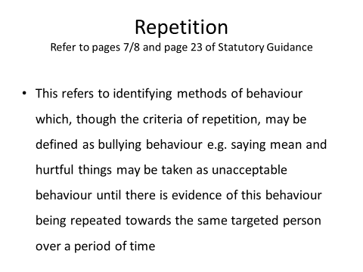

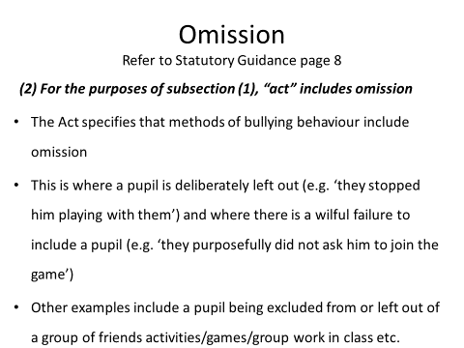

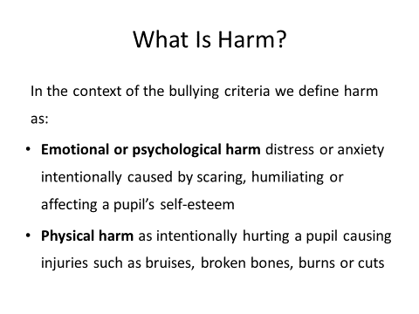

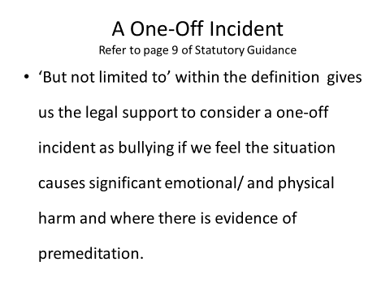

Appendix 3

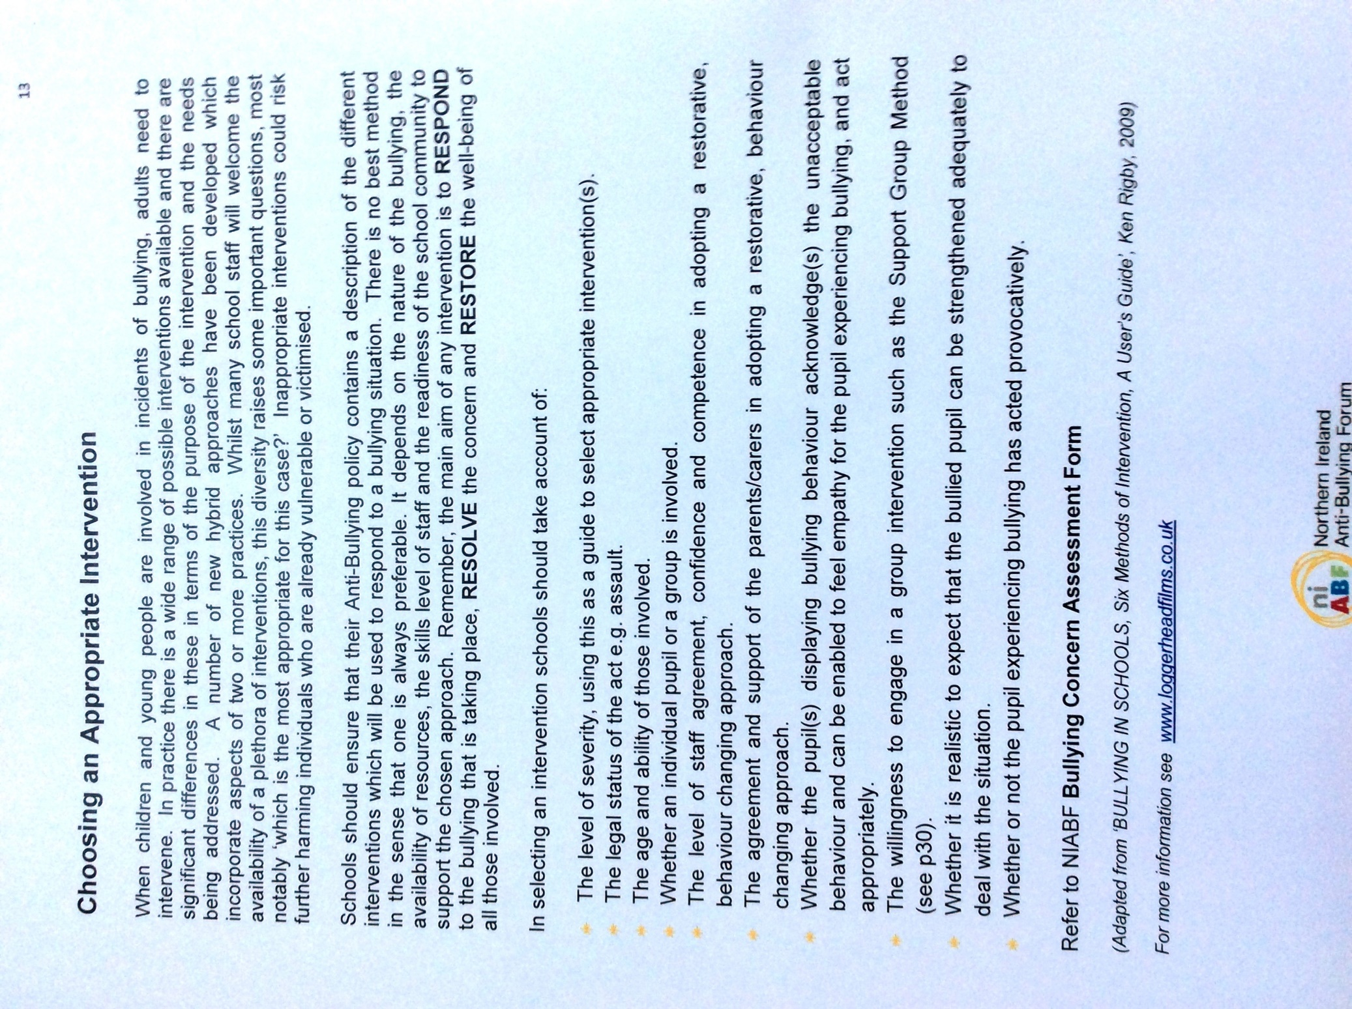

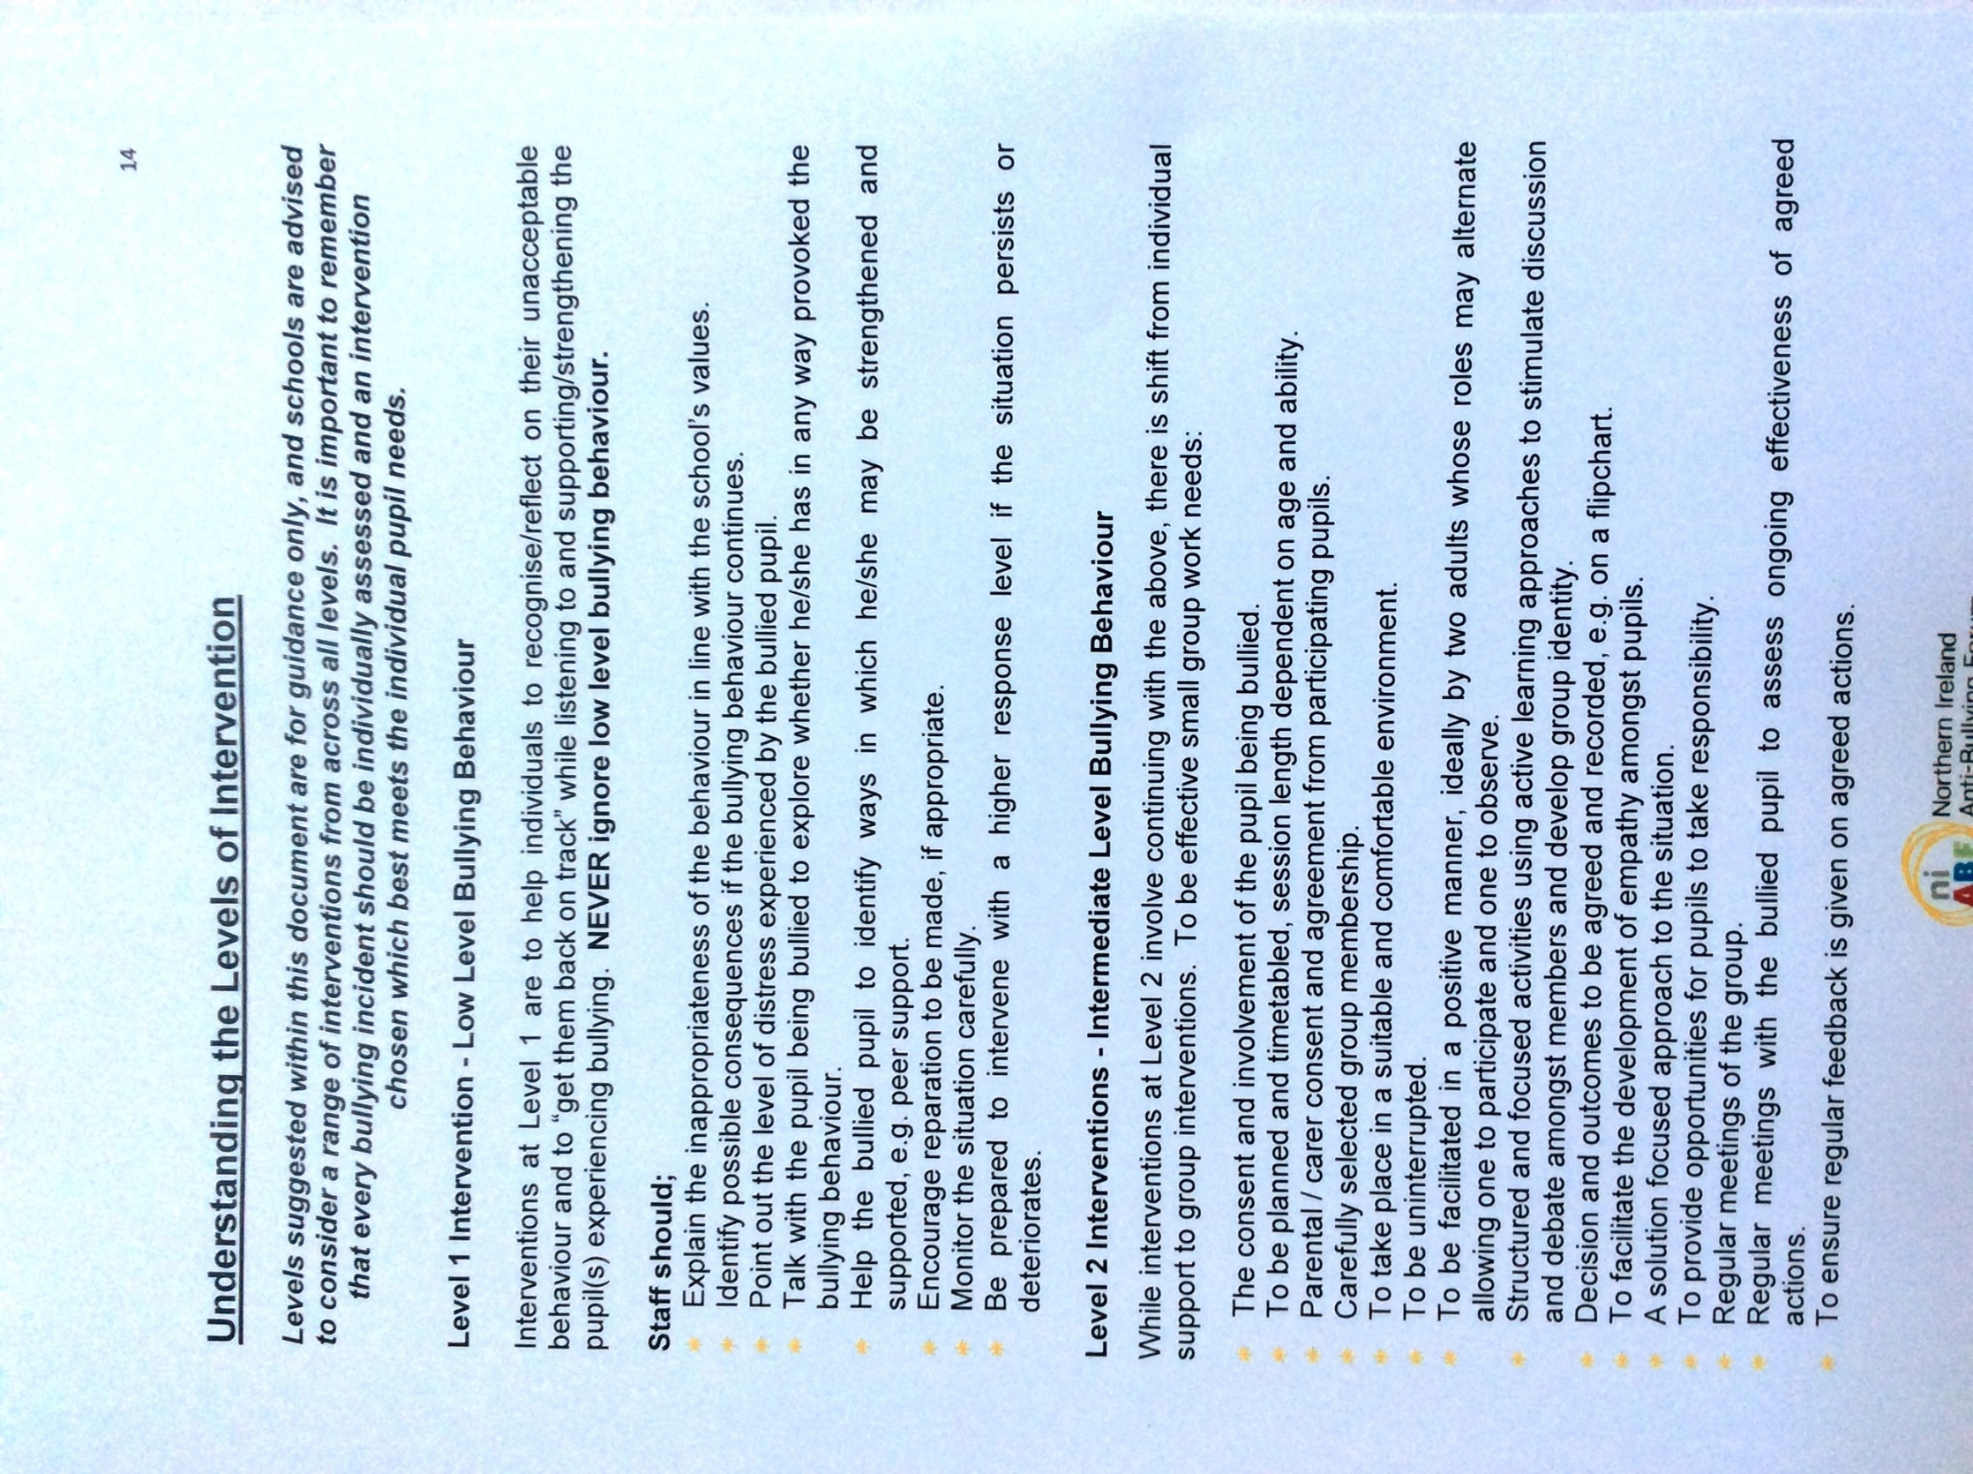

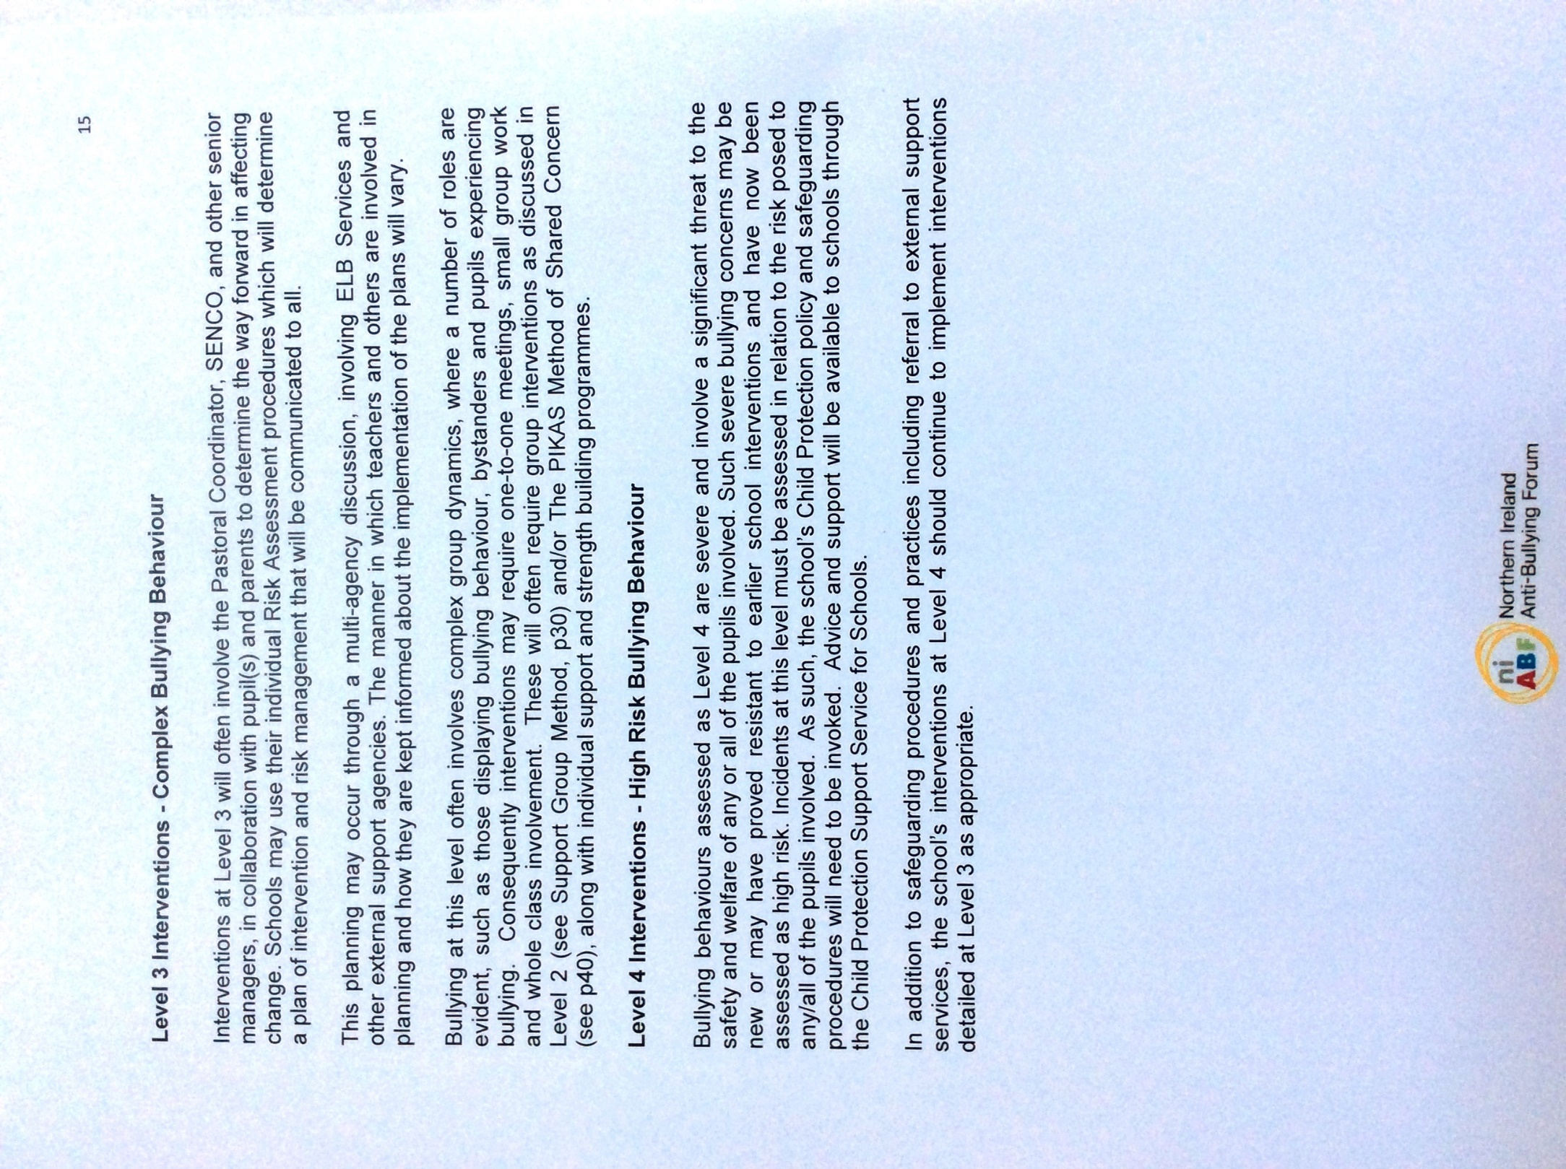

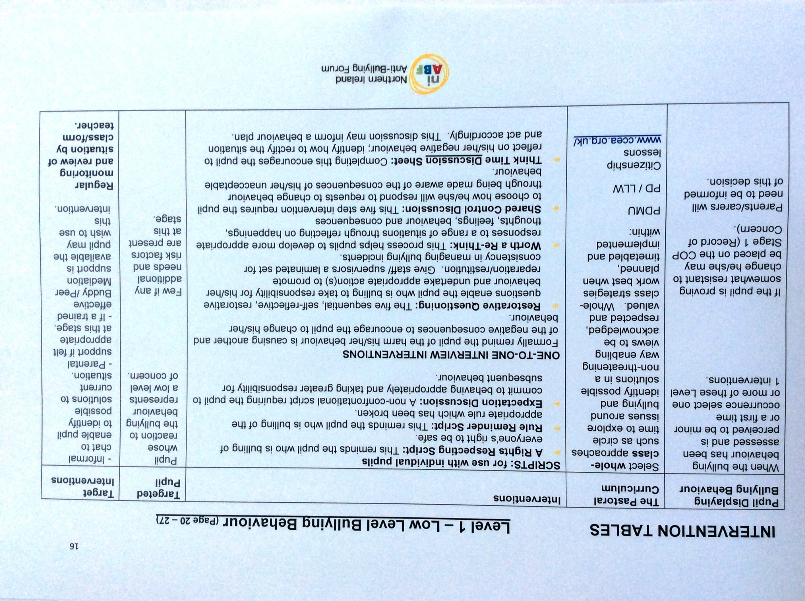

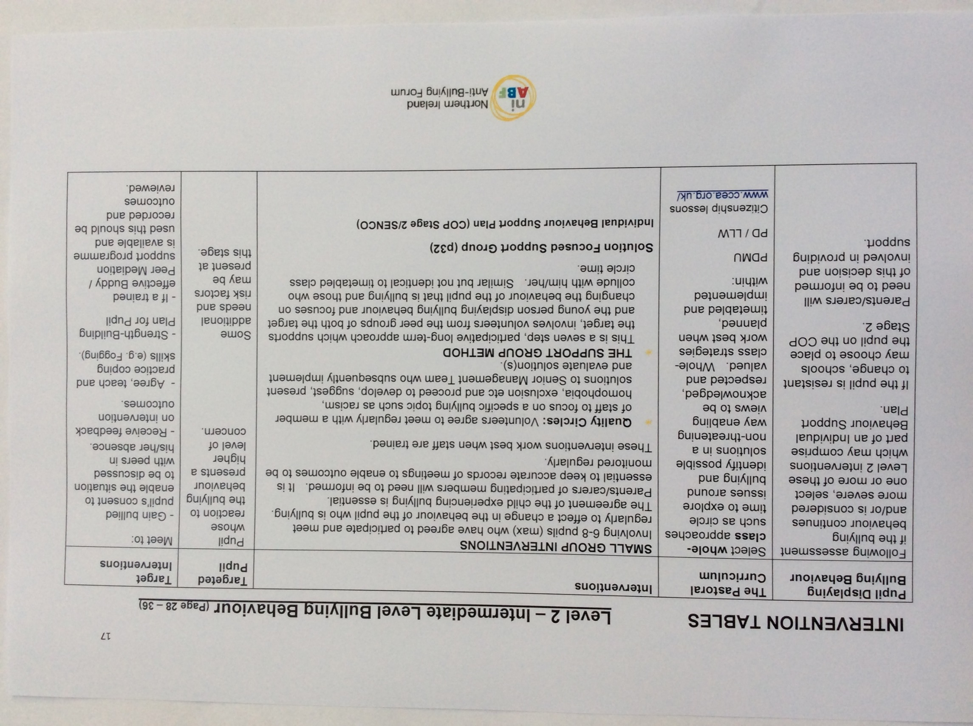

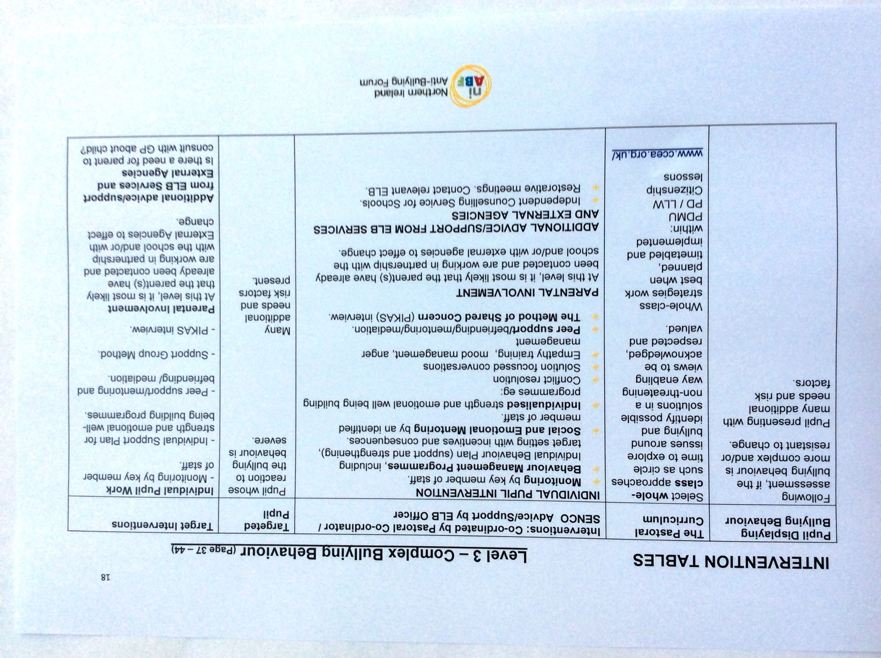

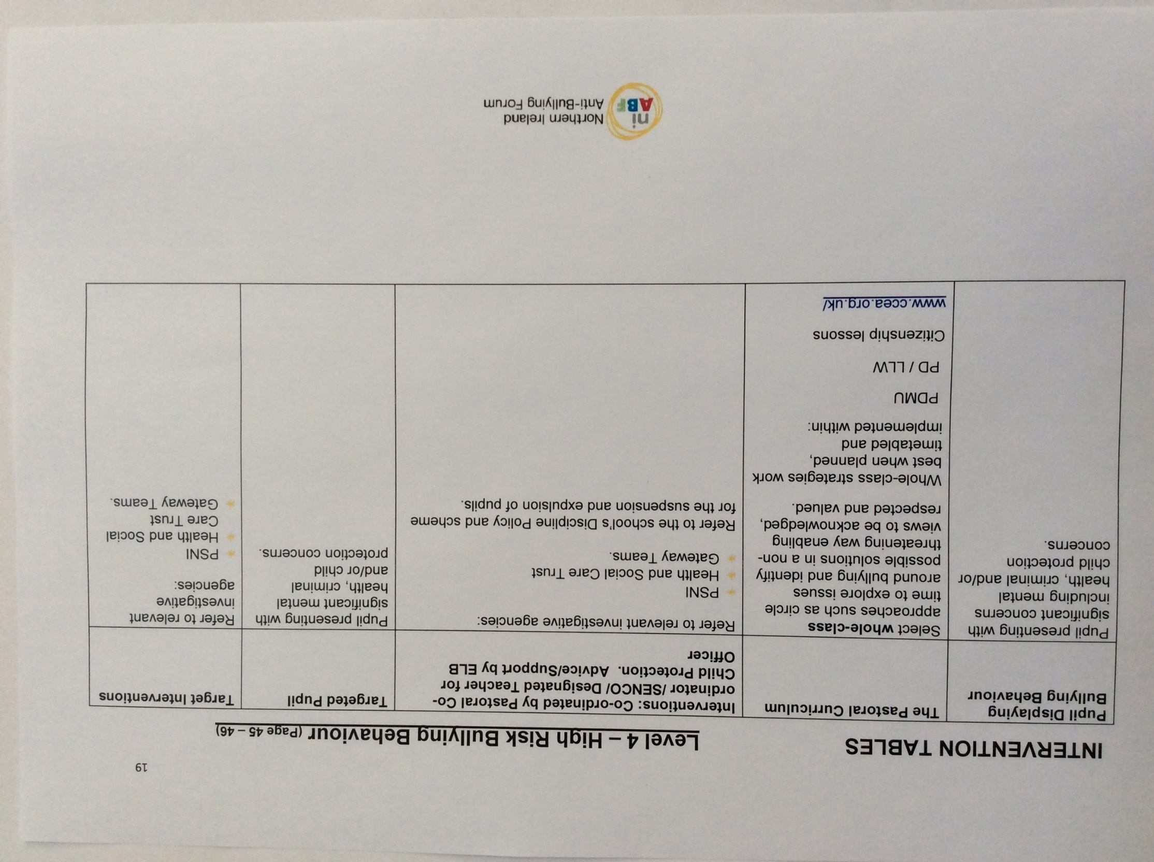

Appendix 4

Bullying Incident Report Form

Name of Pupil Class

Date

Details of incident

Incident reported to

Action taken

Signed by

Class Teacher

Pupil

Head of Key Stage

Parent

Appendix 5

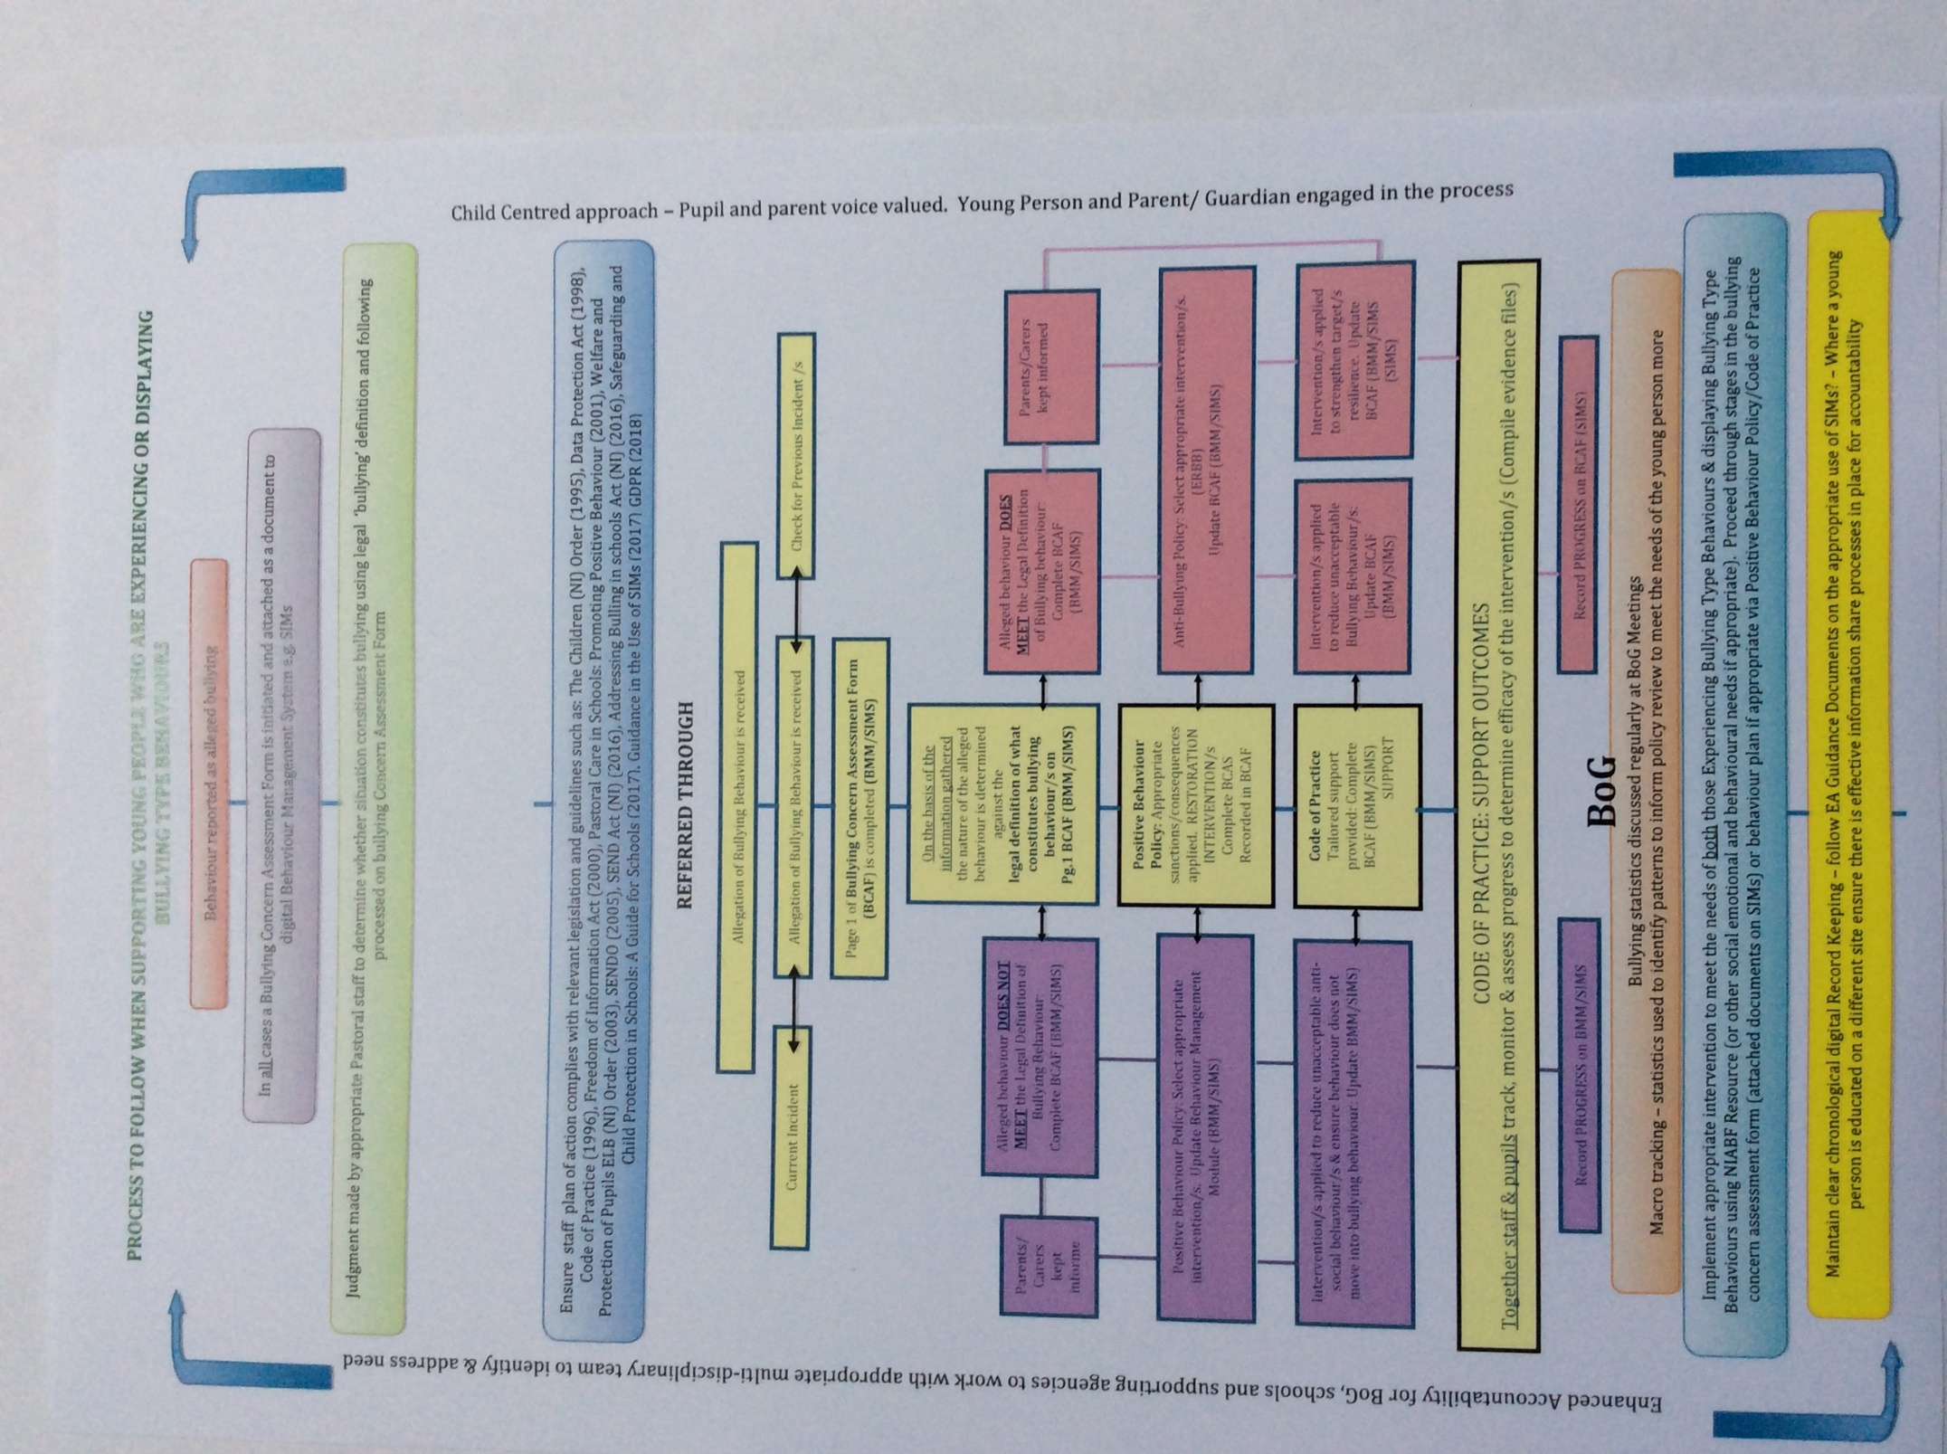

Appendix 6

Examples of ‘Scripting’-
(Agreed questioning strategy to promote consistent approach to challenging pupils about their behaviour in a non-threatening manner.)
The number of questions, vocabulary used etc. will vary with a pupil’s age and ability to process self-reflection.

In order…..

1 Tell me what happened?

2 What were you thinking that led you to behave in that way?

3 Who/what has been affected by what you have done?

(If behaviour is directed towards pupils/adults ask)
4 Can you tell me how -------- has been affected by your behaviour?

5 Which rule/part of our School Rules have you broken?

6 What do you think you need to do to make things right?

Other self-reflection techniques include ‘Worth a Re-Think’ & ‘Think Time Sheet’ Page 26&27 - Northern Ireland Anti-Bullying Forum (NIABF) file ‘Effective Responses to Bullying Behaviour’.

Appendix 7

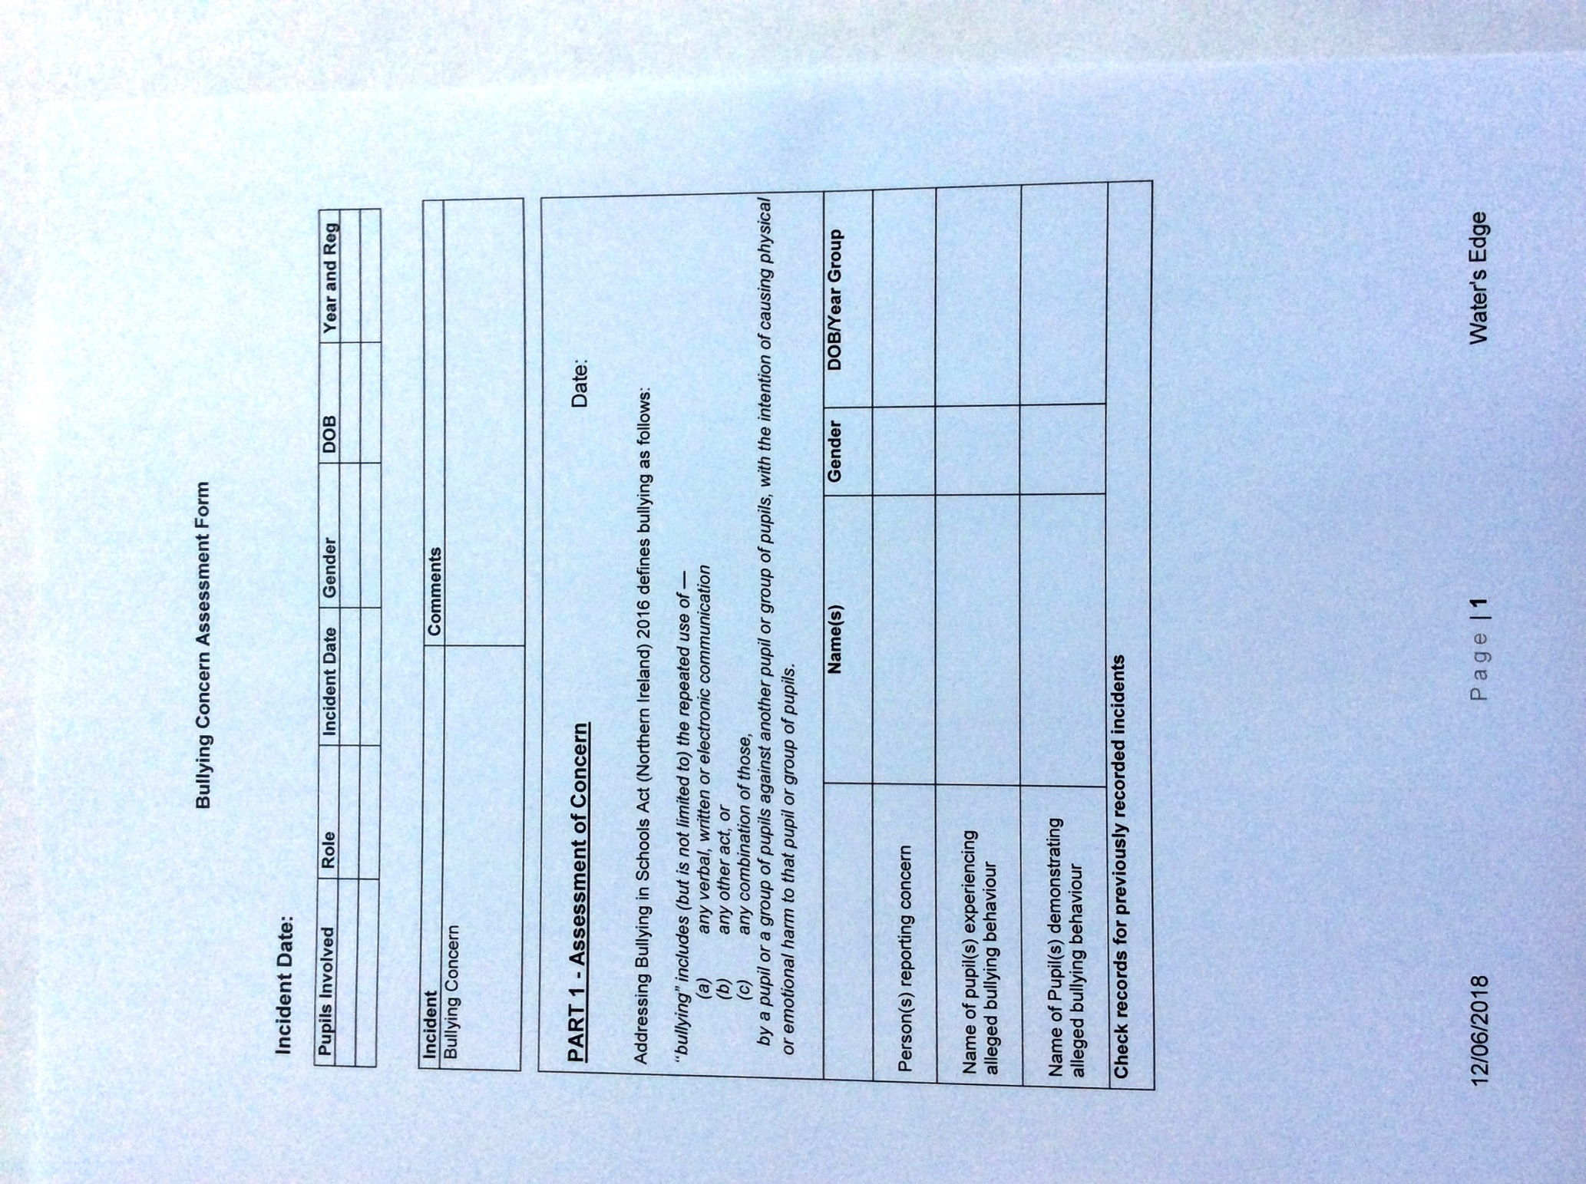

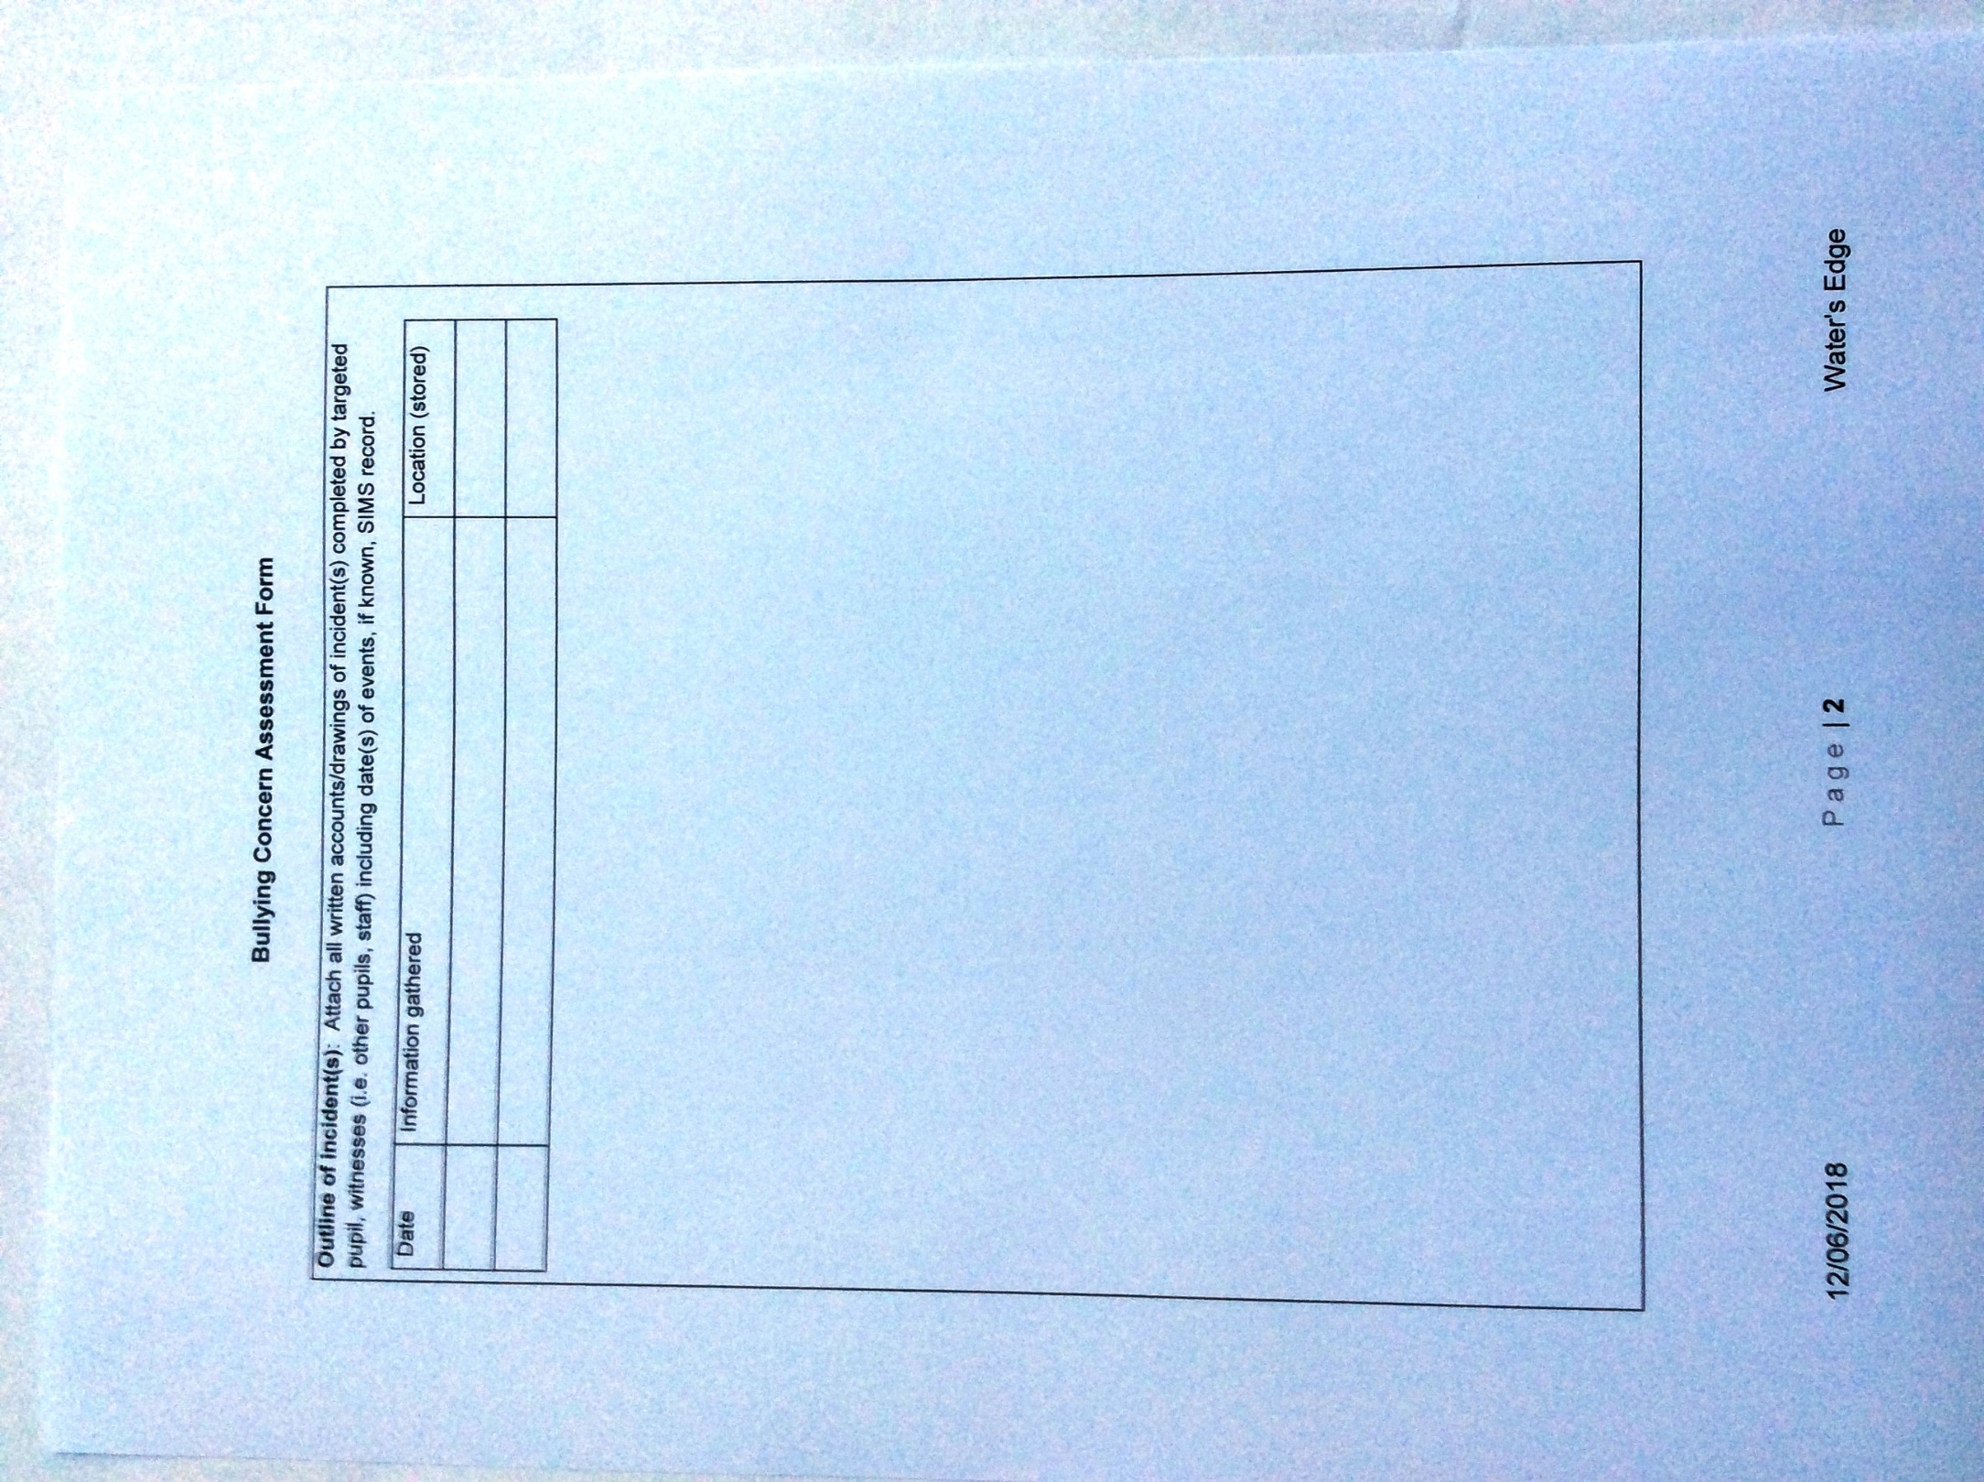

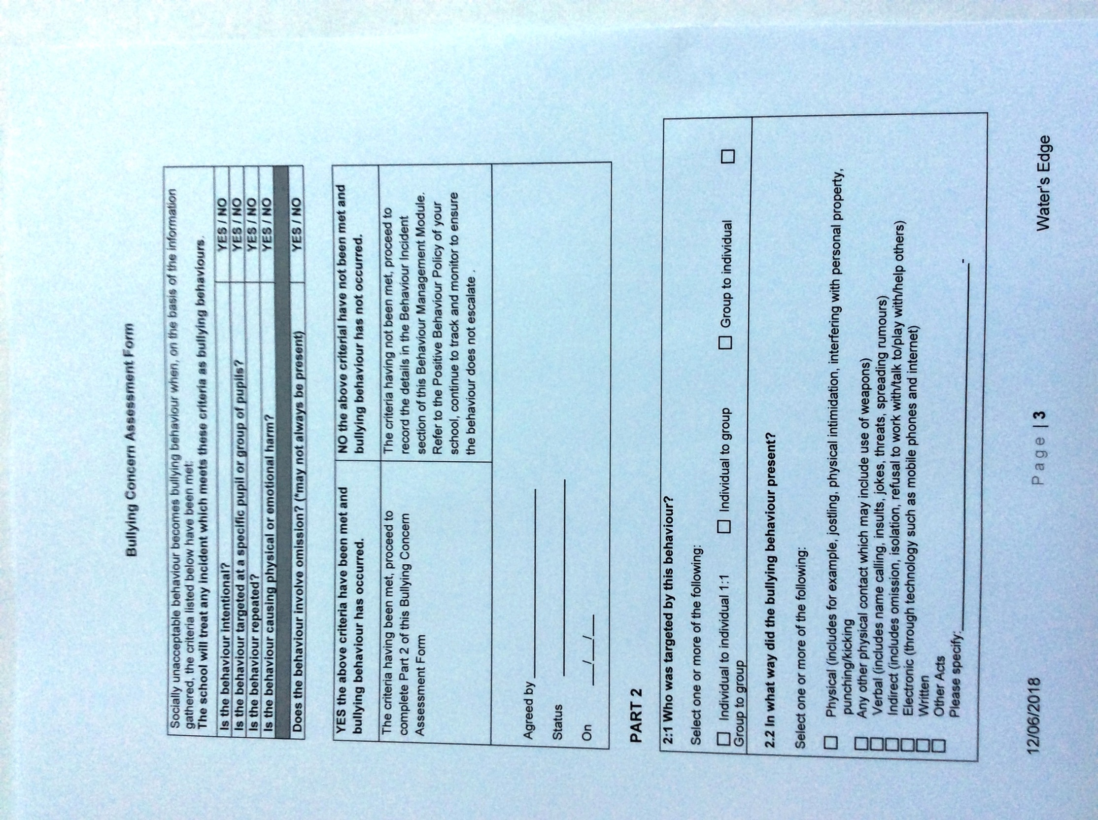

Appendix 8

There are various motivations behind bullying, including those named in the Act. These include, but are not limited to:
- Age
- Appearance
- Breakdown in peer relationships
- Community background
- Political affiliation
- Gender identity
- Sexual orientation
- Pregnancy
- Marital status
- Race
- Religion
- Disability / SEN
- Ability
- Looked After Child status
- Young Carer status

