THE GIFT OF READING
SUMMER SCHOOL

READING SUPPORT AND ASSISTANCE

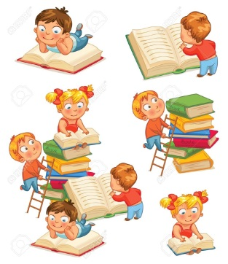
Does your child need help with reading?

The Gift of Reading programme provides individual support and assistance to primary school children experiencing difficulties with reading. Names are now being taken for its One to One Reading Support Programme. For further details and to book you child’s place, please telephone:
The Gift of Reading 07544331333

