Education Authority
Principal: Mrs. M Ramsey
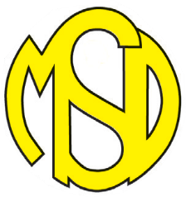
MODEL SCHOOL Northland Road, Derry,
BT48 7HJ.

Telephone: (028) 7126 2188
Fax: (028) 7137 3418
Website: www.modelps.co.uk

25/11/20

In light of a recent complaint to HSENI from a parent/guardian regarding safety regulations around Covid can I reassure you that all procedures that were put in place in the ‘Return to School Guidance’ dated 19th August are still firmly in place.
- Children are collected at 5 different times in the afternoon, as per guidance
1.30pm, 2.00pm, 2.15pm, 2.40pm and 2.55pm.
This is staggered to protect children, staff and parents and also to lessen traffic congestion which is always problematic.

- Signage regarding social distancing is clearly visible in the playground and socially distanced areas for parents to stand in are maintained.

- Once children have been collected and are in your care in the afternoons can I ask you to leave promptly and discourage conversations with other families and children mixing with children from other bubbles.

- Wearing of face coverings is not mandatory outside when dropping off or collecting children however we would encourage parents to wear masks if they wish.
If you have any individual concerns, please do not hesitate to contact me.
Safety of our children, staff and parents/guardians is of paramount importance.
Currently all staff and children are Covid free and this is a great testament to our combined efforts in following all guidance.
Mrs Ramsey

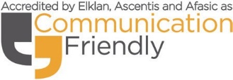
Nurturing Inclusive Celebrating Cultural Diversity Holistic Caring

